HAMLET 1.2

Teaching Notes for a Close Reading Exercise

- Vocabulary

Current words
 | line | word
1 | 2 | green
2 | 2 | befit
3 | 11 | auspicious
4 | 13 | dole
5 | 81 | visage
6 | 86 | trappings
7 | 91 | filial
8 | 107 | unprevailing
9 | 114 | retrograde
10 | 125 | jocund
11 | 132 | canon
12 | 195 | marvel
13 | 204 | truncheon
14 | 231 | countenance

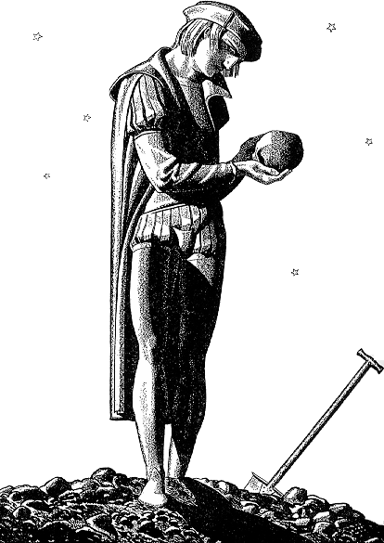
Obsolete words
 | line | word
1 | 20 | disjoint
2 | 32 | levies
3 | 32 | lists
4 | 33 | subject
5 | 38 | delated
6 | 68 | nighted
7 | 79 | suspiration
8 | 115 | beseech
9 | 127 | bruit
10 | 141 | beteem
11 | 155 | galled
12 | 168 | in faith
13 | 177 | I prithee
14 | 147* | or ere/ever
15 | 184* | methinks
16 | 189 | yesternight
17 | 193 | attent
18 | 200 | cap-a-pé
19 | 229 | beaver
19 | 243 | perchance
20 | 248 | tenable

Danger words
 | line | word
1 | 8 | sometime
2 | 8 | sister
3 | 14 | barred
4 | 39 | commend
5 | 50 | dread
6 | 51 | leave (n.)
7 | 62 | fair
8 | 74 | common
9 | 92 | obsequious
10 | 109 | immediate
11 | 137 | merely
12 | 167 | 'good even'
13 | 207 | dreadful
14 | 209 | deliver
15 | 238 | tell
16 | 244 | person

- Familiar and Formal Address

Characters who use formal address:
Speaker |  | addressed | form | line
King | to | assembly | your | 15
King | to | assembly | you | 17
King | to | Cor & Volt | you | 34
King | to | Cor & Volt | you | 36
King | to | Cor & Volt | your | 39
King | to | Cor & Volt | your | 39
King | to | Laertes | you | 42, 43, 44, 45
Laertes | to | King | your | 51, 53, 56
King | to | Laertes | you | 57, 57
Polonius | to | King | you | 61
King | to | Hamlet | you | 66
King | to | Hamlet | your | 87, 88, 89, 112
King | to | Hamlet | you | 89, 106, 109, 12, 115, 115
Hamlet | to | Queen | you | 120
Hamlet | to | Horatio | you | 160
Horatio | to | Hamlet | your | 160
Horatio | to | Hamlet | your | 162
Hamlet | to | Horatio | you | 163, 164
Hamlet | to | Horatio | you | 167, 168
Hamlet | to | Horatio | your | 170, 172, 174
Hamlet | to | Horatio | you | 171, 173, 175, 175
Hamlet | to | Horatio | yourself | 173
Horatio | to | Hamlet | your | 176
Horatio | to | Hamlet | your | 191
Horatio | to | Hamlet | your | 193
Horatio | to | Hamlet | you | 195
Horatio | to | Hamlet | your | 199
Horatio | to | Hamlet | your | 211
Hamlet | to | Horatio | you | 213
Horatio | to | Hamlet | you | 223
Hamlet | to | Horatio | you | 225
Hamlet | to | Mar & Bar | you | 226
Hamlet | to | Horatio | you | 228
Hamlet | to | Horatio | you | 233
Hamlet | to | Horatio | you | 235
Hamlet | to | Horatio | you | 245, 246
Hamlet | to | Group | your | 247, 250
Hamlet | to | Group | you | 250, 252
Group | to | Hamlet | your | 252
Hamlet | to | Group | your | 253

Characters who use ‘familiar’ address:
Speaker |  | addressed | form | line
King | to | Laertes | thou | 45
King | to | Laertes | thy | 49
King | to | Laertes | thou | 50
King | to | Laertes | thy | 49
King | to | Laertes | thine | 62
King | to | Laertes | thy | 62
King | to | Laertes | thy | 63
King | to | Laertes | thy | 63
Queen | to | Hamlet | thine | 68
Queen | to | Hamlet | thy | 68
Queen | to | Hamlet | thy | 70
Queen | to | Hamlet | thy | 71
Queen | to | Hamlet | thou | 72
Queen | to | Hamlet | thee | 75
Queen | to | Hamlet | thy | 118
Queen | to | Hamlet | thee | 119
Hamlet | to | "Frailty" | thy | 146

The exchange between Claudius and Laertes
Speaker |  | addressed | form | line
King | to | Laertes | you | 42, 43, 44, 45
King | to | Laertes | thy | 45
King | to | Laertes | thou | 45
King | to | Laertes | thy | 46
King | to | Laertes | thy | 49
King | to | Laertes | thou | 50
Laertes | to | King | your | 51, 53, 56
King | to | Laertes | you | 57, 57
Polonius | to | King | you | 61
King | to | Laertes | thy | 62
King | to | Laertes | thine | 62
King | to | Laertes | thy | 63
King | to | Laertes | thy | 63

Summary
The familiar forms are used only by the King on Laertes, by the Queen to Hamlet, and by Hamlet in apostrophe.

- Prosody

The entire scene is in verse except for part of the exchange about the ghost. Lines to look at are:
Lines | 165-166 | Hamlet and Marcellus
Line | 190 | Hamlet’s question
Lines | 227-228 | Hamlet with Marcellus and Barnardo
Line | 230 | Hamlet’s question
Line | 232 | Hamlet’s question
Lines | 235-236 | Horatio and Hamlet’s question
Line | 238 | Marcello and Barnardo

- Shared Lines

Line | Begun by |  | Ended by
50 |  | King | Laertes
74 |  | Hamlet | Queen
160 |  | Horatio | Hamlet
185 |  | Horatio | Hamlet
191 |  | Horatio | Hamlet
195 |  | Horatio | Hamlet
212 |  | Horatio | Hamlet
214 |  | Hamlet | Horatio
220 |  | Horatio | Hamlet
225 |  | Hamlet | Mar & Bar
226 |  | Hamlet | Mar & Bar
Line |  | Begun by | Ended by
233 |  | Horatio | Hamlet
234 |  | Horatio | Hamlet
239 |  | Horatio | Hamlet
241 |  | Horatio | Hamlet
242 |  | Hamlet | Horatio
252 |  | Hamlet | Group

Line 226 is split three ways—begun and ended by Hamlet with an intervening speech by Marcellus and Barnardo.

- Rhetorical Style

The organization of the King’s opening to the “court scene”
Lines | Area | Topic
1-7 | Succession | Old Hamlet's death
8-16 | Succession | Marriage
17-25 | International | Norway's threat
26-41 | International | The mission to Norway
42-63 | The Court | Leartes's petition
64-105 | Family | Hamlet's grief
106-122 | Family | Hamlet as heir and son
123-128 | Ending | The celebration

